sub:Git Branching Strategies

Step1: create the folder and add files to it

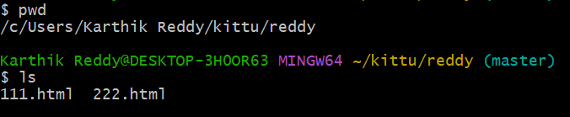

Step2: create the new branch name



Simple to new branch and direct swift:

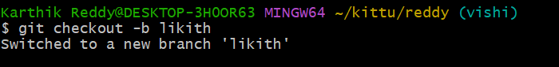

Change the name of the branch:

While changing the branch we want have on the branch and change the branch name

To see the all branches :

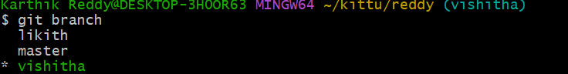

To delete the branch name:

While delete the branch not present in the branch.

What is Cloud Computing?
Someone else's computer/server on the Internet that stores and processes your data.

Real-Life use:
Imagine you have photos on your phone.

Without Cloud
- Photos are stored only on your phone.
- If your phone is lost or damaged, photos may be lost.

With Cloud
- Photos are stored online (cloud).
- You can access them from any phone or computer.
- Even if your phone is lost, your photos are safe.

Why Do We Use Cloud?
- Access data from anywhere.
- Save storage on your device.
- Backup data safely.
- Share files easily.
- Run websites and applications

Cloud Deployment Models:

Public Cloud:

Cloud services are available to everyone over the Internet.
Real-life example: Public bus that anyone can use.

Private Cloud:
Cloud that can is used by only one organization.
Real-life example:Your own private car.

Hybrid Cloud:
Combination of Public Cloud and Private Cloud.
Real-life example:Using your own car for daily travel and a taxi when needed.

